Template for Evidence(s)
UI GreenMetric Questionnaire

University : ...
Country : ...
Web Address : …

[5] Transportation (TR)
SAMPLE
[5.13] Ratio of Parking Area to Total Campus Area (TR.5)

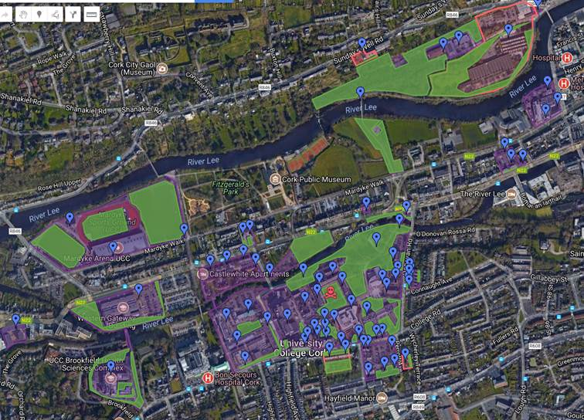
Example of Ratio of Parking Area to Total Campus Area (University College Cork, Ireland)
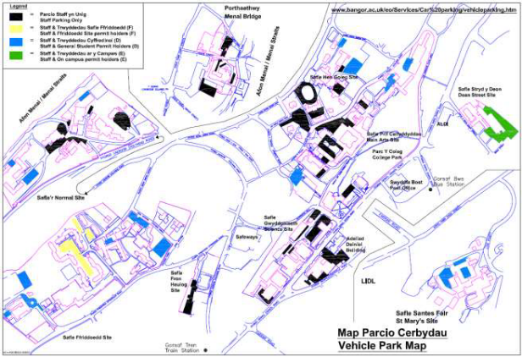
Example of Ratio of Parking Area to Total Campus Area (Bangor University, UK)

Description:
(Please describe the ratio of parking area to total campus area. The following is an example of the description. You can describe more related items if needed.)

The evidence provided may also include maps showing the location, area size, or distribution of facilities relevant to the indicators

Total main campus area: 740,300 m²
Total parking area = 19525m² (1562 spaces*12.5m² per space).
Ratio = 0.026

Additional evidence link (i.e., for videos, more images, or other files that are not included in this file):

